ECA5403-ELECTROMAGNETIC FILEDS AND WAVES
S. Rupika
192512398
C01-5
EXPERIMENT 5
AIM:
To write program for Electric potential difference between two points in free space medium using MATLAB.

Test case (i) Determination of electric potential difference between two points for a given charge

Program:
clc; clear;
q=input("Enter the q value:"); epsilon=8.854*10^-12; k=1/(4*pi*epsilon); ax=input('Enter the value of ax='); ay=input('Enter the value of ay='); r1=sqrt(ax^2+ay^2);
v1=k*q/r1;
disp('The value of v1'); disp(v1);
bx=input ('Enter the value of bx='); by=input ('Enter the value of by='); r2=sqrt(bx^2+by^2);
v2=k*q/r2;
disp('The value of v2'); disp(v2);
v=v1-v2;
disp ('The electric potential difference is'); disp (v);
% Plot: potential versus radial distance and potential difference between r1 and r r = linspace(0.1,10,50);
V = k*q./r; % V = kq/r figure;
plot(r,V,'LineWidth',2); hold on; plot(r1,v1,'ro','MarkerFaceColor','r'); grid on; xlabel('Radial distance r (m)'); ylabel('Potential V (V)'); title('Potential V = kq/r'); legend('V(r)','V1 at r1'); figure;
plot(r,k*q*(1/r1 - 1./r),'LineWidth',2); grid on;
xlabel('Radial distance r (m)'); ylabel('Potential difference V1 - V(r) (V)'); title('Potential difference between r1 and r');
% Independent check: E = -dV/dr (numerical gradient) compared with E = kq/r^2 rc = linspace(1,10,2000);
E_num = -gradient(k*q./rc,rc); E_th = k*q./rc.^2;
dev = max(abs(E_num(2:end-1) - E_th(2:end-1))./E_th(2:end-1))*100; fprintf('Maximum deviation between -dV/dr and kq/r^2 = %.4f %%\n', dev);

Output:-
Enter the q value: 2e-2 Enter the value of ax=1 Enter the value of ay=4
The value of v1
4.36 × 10⁷
Enter the value of bx=36 Enter the value of by=64
The value of v2
2.45 × 10⁶
The electric potential difference is
4.11 × 10⁷
Maximum deviation between -dV/dr and kq/r^2 = 0.0020 %

OUTPUT:
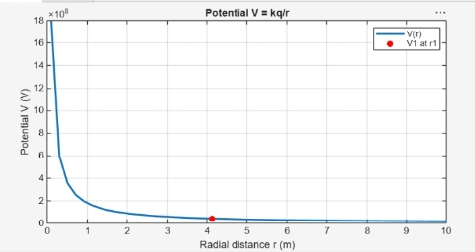

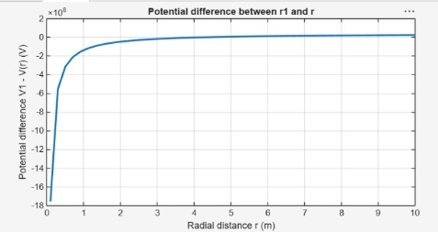

Test case (ii)
A positive charge with fixed r₁ = 1 m and r₂ varying.

Program:

clc; epsilon=8.854e-12;
k=1/(4*pi*epsilon); q=1e-6;
r1=1;
r2=linspace(1.1,10,100); V=k*q*(1/r1 - 1./r2); plot(r2,V,'LineWidth',2);
xlabel('r2 (m)');
ylabel('Potential Difference (V)'); title('Positive charge, fixed r1');

Output

- Potential difference increases with increasing r₂

OUTPUT:
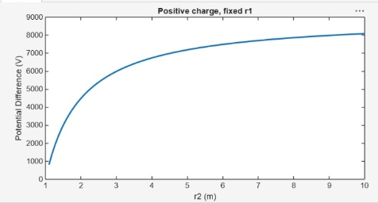
Test case (iii) A negative charge with fixed r₁ and varying r₂:

Program:
clc; epsilon=8.854e-12;
k=1/(4*pi*epsilon); q=-1e-6;
r1=1;
r2=linspace(1.1,10,100); V=k*q*(1/r1 - 1./r2); plot(r2,V,'LineWidth',2);
xlabel('r2 (m)');
ylabel('Potential Difference (V)'); title('Negative charge, fixed r1');

Output:-
- Potential difference becomes negative
- Same trend but inverted
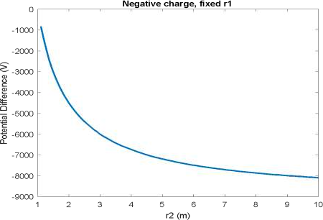
Test case (iv) Both r₁ and r₂ varying with positive charge 3:

Program:
clc; epsilon=8.854e-12;
k=1/(4*pi*epsilon); q=1e-6;
r1=linspace(0.5,5,100); r2=linspace(5,10,100); V=k*q*(1./r1 - 1./r2); plot(r1,V,'LineWidth',2);
xlabel('r1 (m)');
ylabel('Potential Difference (V)'); title('Both r1 and r2 varying');
Output: Potential difference varies non-linearly

